Unsubscribe? Please click **here** <%unsubscribe_link%>

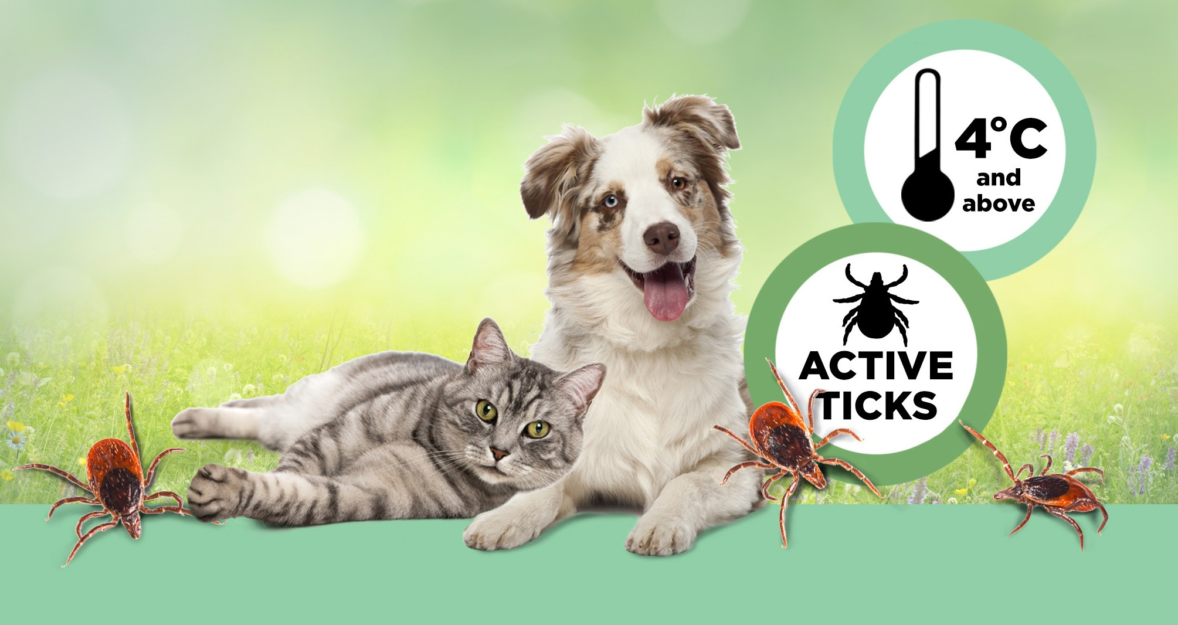

**Help keep {pet_name} tick free**

Dear {first_name},

Ticks are out looking for a host to feed on when temperatures reach 4°C, no matter what season it is.

Our records indicate we prescribed **BRAVECTO®** for {pet_name}’s flea and tick control. If you need additional doses of **BRAVECTO®**, or if you have any questions, please contact us.

To learn more about **BRAVECTO®** you can contact us, or if you have the drug identification number (DIN), visit Bravecto.ca.

{practicename}

{website}

{contactemail}

{contactphone}

{add1}

{add2}

{town}, {province} {postcode}