**COVID-19 alert:** For safety reasons, be sure to contact us before each visit.

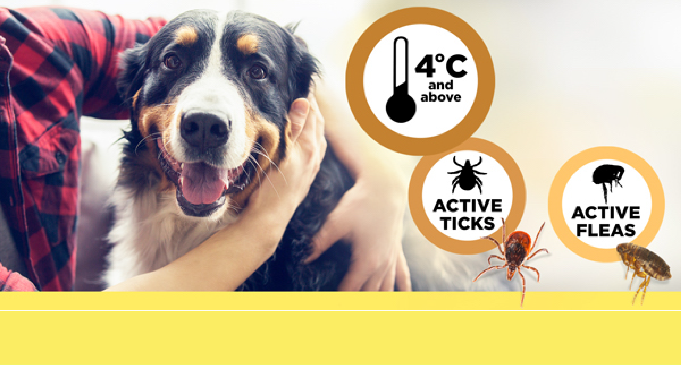

**It’s time to pick up {pet_name}’s BRAVECTO® refill**

Dear {first_name},

Our records indicate that it will soon be **12 weeks** since **BRAVECTO®** was given to {pet_name}. It may be time for another dose. If you need additional doses of **BRAVECTO®** please contact us.

To learn more about **BRAVECTO®** you can contact us, or if you have the drug identification number (DIN), visit [Bravecto.ca](https://www.bravecto.ca/en).

{practicename}

{website}

 {contactemail}  {contactphone}

{add1}

{add2}

{town}, {province} {postcode}

Unsubscribe? Please click **here**.